**POLS 095**

**Methods in Politics**

**Spring 2022  
Dr. Gregory J. Wolf**

**Homework 5**

**NOTE: This homework contains two sections, one that is more conceptual and one that is utilizes R. The conceptual portion is worth 200 points and the R portion is worth 100 points, for a total of 300 points. Your score on this homework is the percent of points earned out of 300.**

When typing your answers, please use a different font or font color to distinguish your answers from the question.

***Part I: Conceptual Questions (200 pts. total)***

For questions 1 and 2 below, do each of the following for the proposed relationships: (180 pts.)

1. Write a hypothesis for the relationship that you expect to see. (Use the textbook format we’ve been using all semester).
2. Explain what the scatterplot tells you. Based on the scatterplot, what do you expect for the correlation coefficient’s direction and strength (e.g., propose a value of the correlation coefficient from -1 to 1 and explain why you chose that value)? (Remember that your independent variable should be on the X-axis and the dependent variable on the Y-axis).
3. What would the correlation coefficient tell you (based on your guess)?
4. Interpret the regression for the relationship. Explain what the numbers mean, including the predicted value of the dependent variable when the value of the independent variable is 0 (the intercept), and the predicted change in the dependent variable for every 1 unit increase in the independent variable.
5. Identify at least one “control variable” for the hypothesis (for question 1 only). What is something that is not included in this analysis that could also explain the dependent variable? Explain why you believe that variable is important and what you would expect to find if that variable were included in the regression and why.
6. Do the results surprise you? (for question 1 only)
7. Proposed relationships:

* Unit of analysis: states
* Dependent variable: Advantage of conservatives over liberals (% Conservative - % Liberal)
* Independent variable: Percent of population with a college degree
  1. Hypothesis: (10 pts.)

*In a comparison of states, those with a higher percentage of college graduates will be more liberal than states with a less percentage of college graduates.*

* 1. Scatterplot: (15 pts.)

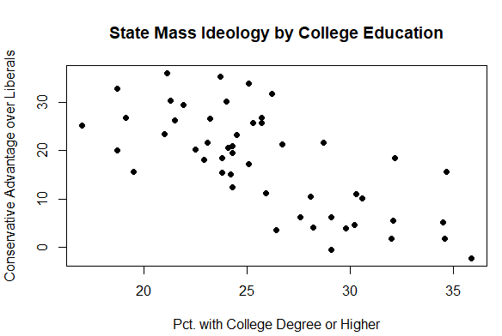

* 1. What would the correlation coefficient tell you? (10 pts.)
  2. Interpret the regression. (25 pts.)  
     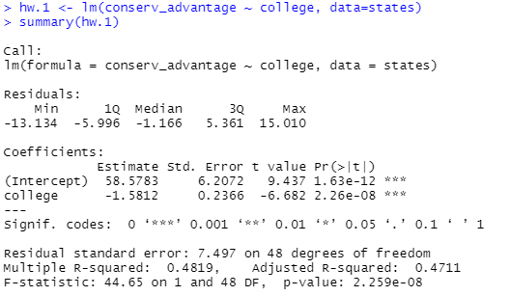

(Note: 2.26e-08 means that the decimal is moved over 8 spots to the left. The p-value for “college” is 0.000000226)

* 1. Identify at least one “control variable” you might want to include and explain why. (10 pts.)
  2. Does the relationships that you find surprise you? Explain why or why not. (10 pts.)

1. Propose relationships:
   * Dataset: world
   * Unit of analysis: country
   * Dependent variable: women13 (percent of women in the countries legislature)
   * Independent variable: womyear (year women gained suffrage)
2. Hypothesis: (10 pts.)
3. Scatterplot: (15 pts.)

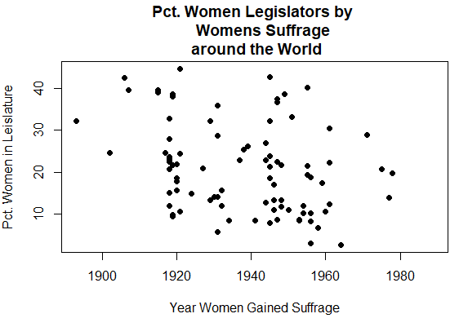

1. What would the correlation coefficient tell you? (10 pts.)
2. Interpret the bivariate regression. (25 pts.)  
   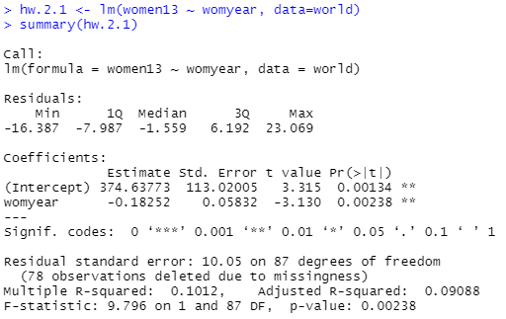
3. There are other factors that are likely to influence how many women serve in legislatures around the world. Upon conducting some research, you find evidence that suggest how democratic a country is affects the proportion of women elected to the legislature. Likewise, you also have reason to suspect that countries with higher GDP will have more women in the legislature than countries with low levels of GDP. To account for these factors, we need to run a multivariate regression that estimates the effect of the year a country gained women’s suffrage on the percentage of women in the legislature, controlling for democracy and GDP. We include the following to control variables:
   * dem_score14:
     + Captures how democratic a county is
     + Ranges from 0 to 10, where higher scores are more democratic and lowest scores are less democrat
   * hi_gdp
     + Classifies countries into two categories: low GDP or high GDP

Interpret the multivariate regression: (35 pts.)

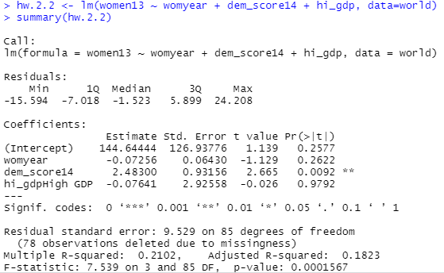

1. Does your assessment of your hypothesis change? Why or why not? (25 pts.)

***R Component*** (100 pts.)

Use the ANES data and the appropriate tests to examine predictors of what social scientists call “racial resentment." This measure is a scale built out of 4 questions (V202300, V202301, V202302, V202303); higher values on this scale indicate higher levels of racial resentment. The independent variables to use are party, ideology, age, education (college degree or not), the seven-point spending and services scale (V201246), and trust in government (V201233). Start by running the code that creates the racial resentment measure and cleans the other variables.

1. Select only White, non-hispanic respondents.

2. Create a model with the racial resentment scale as the dependent vari-

able and trust in government above as the independent variable.

3. Interpret the model results.

4. Add the other variables to the model.

5. Interpret the model results.

6. You should put a well formatted table of your results in this document (do not copy and paste the R output or place a screenshot) along with a paragraph that interprets the results. Additionally, attach your R script to your homework submission.